B.Sc Computer Games Development, Year 3

Game Design Document

06- Oct-2021

**“SHHHHHH...!”**

Authors: Masih Shafieian , Eoin Galavan , Adrien Dudon

Project Supervisor: Peter Lowe

# 

Table of contents



1. Overview

**1.1.** **The Elevator Pitch / High Concept**

**1.2.** **Theme, Setting and Genre**

This is a top down stealth survival game. The setting is a zombie infested island you need to escape from

**1.3.** **Player Experience Goals**

**1.4.** **View**

**1.5.** **Targeted platform(s)**

**1.6.** **Technical requirements(s)**

2. Gameplay

**2.1.** **The First Minute (60 seconds of play)**

**2.2.** **Game progression**

**2.3.** **Level progression**

**2.4.** **Objectives/Victory Conditions**

3. Features

3.1. Sprint 1

**Feature 1** - Moving player

**Feature 2 -** Enemy

**Feature 3 -** Environment

**Feature 4 -** Noise

**Feature 5 -** Pickups

**Feature 6 –** Enemy vision cone

**Feature 7 –** Camera

**Feature 8 –** Animations

4. **Game World**

4.1. Game Geography

4.2. Game World Elements

4.2.1. Characters (Player and Enemies)

4.2.2. Items

5. **Levels**

5.1 Level description

6. **Interface**

6.1. Controls

6.2 HUD

6.3 Screenflow

6.4 Control system

7. AI

7.1. Opponent AI

8. **Game Art & Audio**

8.1. Audio

**8.2.** **Art assets**

**8.2.1.** **Characters/ animation frames**

**8.2.2.** **Items (in-game & icons)**

**8.2.3.** **Level backgrounds/maps/environment textures**

8.2.4. **Visual effects**

**8.2.4.1.** **Particles**

**8.2.5.** **HUD graphics, typeface**

8.2.6. **Controls screen/menu/dialog backgrounds/borders/typefaces**

# Overview

### **The Elevator Pitch / High Concept**

SHHHHHH…...!!!! is a two-dimensional top-down view game where the player needs to obtain avoid zombies to escape from the zombie island!

### **Theme, Setting, and Genre**

### This is a top-down stealth survival game. The setting is a zombie-infested island you need to escape from

### 

### **Player Experience Goals**

Players have to avoid the zombies, search and find the goal to escape the island.

### **View**

### 

The game will have a top-down view, with the player in the center and the camera moving with the player.

### 

### **Targeted platform(s)**

Windows 10 minimum

### **Technical requirements(s)**

* Personal computer
* C++ languages with SFML library
* Visual Studio or JetBrains CLion as IDE

# Gameplay

### **The First Minute (60 seconds of play)**

The Player opens up the game and sees the menu, it has 3 options(Play, Help, Exit), the player clicks Help and reads how the games controls work before returning to the menu, the player then clicks play and is presented with the first level, this level is mostly empty, to the left there is 4 tiles of terrain, upon stepping on them the player sees sound waves of varying size start to appear, if the player changes speed they also notice this effects speed, they then move down to a bottle, upon colliding with it it moves to the bag, then then hold the control button and upon release the bottle gets thrown against the nearby wall, this creates noise also, finally to the right they notice a zombie is facing away, they walk behind it and it doesn’t see the player but it reacts to the noise and starts to chase the player, when it catches the player the game transitions to a game over screen

## **Game progression**

* + 1. *How do I progress from level to level?*The level is completed when you reach the goal, if there is another level a new one gets loaded
    2. *How does the game increase in difficulty?*

Adding more enemies and changing the environment.

* + 1. *What rewards (useful or not) are revealed to keep players engaged?*

Players are given success screens upon each levels completion and a congratulations once all levels are beaten

## **Level progression**

* + 1. *How do I complete each level? I.e. what are the objectives*

After the player reaches the goal the level is completed and can progress to the next one.

## **Objectives/Victory Conditions**

The main objective is to reach the goal

The game will finish when all the levels have been beaten. However, replayability is available.

The player loses the level if they get caught by the zombies and may restart.

The goal of the game is to reach the goal and escape the zombie island by completing each level.

# Features

## Sprint 1

### **Feature 1** - Moving player

The player should be drawn and move in the 4 cardinal directions.

**Conditions of satisfaction:**

* I can use keyboard arrows to move
* The Player can be seen on the screen.
* The player can Sneak and Run as well.

### **Feature 2 -** Enemy

The enemy should be drawn on the screen and can interact with the player.

**Conditions of satisfaction:**

* Enemies can be seen on the screen.
* If a player collides with the enemy a game over text will appear
* Enemy moves towards Noise it hears

### **Feature 3 -** Environment

various static features of the map that the player can interact with.

**Conditions of satisfaction:**

* The environment can be seen on the screen.
* Collision between player and the environment.
* Creating different children of environment-class.
* Noise is created on ground that the player walks on

### **Feature 4 -** Noise

The player can make noises or create noises with the environment within the level. There are three levels of noises: green, yellow, and red that depend on what's been interacted with

**Conditions of satisfaction:**

* When the player walks on or interacts with something noise is generated
* Noise is drawn on the players' location and expands over time
* Noise is deleted when it hits its maximum size
* A zombie that hears the noise can react appropriately

### **Feature 5 -** Pickups

the player can interact and pick up certain objects.

**Conditions of satisfaction:**

* The Player can see the different pickups.
* The player can interact with the pickups if they collide with them.
* Certain items are throwable
* And another that triggers the win conditions.

### **Feature 6 –** Enemy vision cone

One of the enemies has a vision cone and can see the player. Upon player entering the cone the idle enemy vision cone angle and length will change (goes to attack mode) and will follow the player, if it catches up to the player it will attack the player. If the player manages to leave the vision cone, the vision cone will go back to its previous state (seeking state).

**Condition of satisfaction:**

* Enemy reacts immediately to a player entering its vision cone.
* it changes its states successfully.

### **Feature 7 –** Camera

The camera (the view) should follow the player smoothly. There should be a “free area” where the camera does not move. If the player reaches one of the borders of the area, the camera should start moving smoothly toward the player.

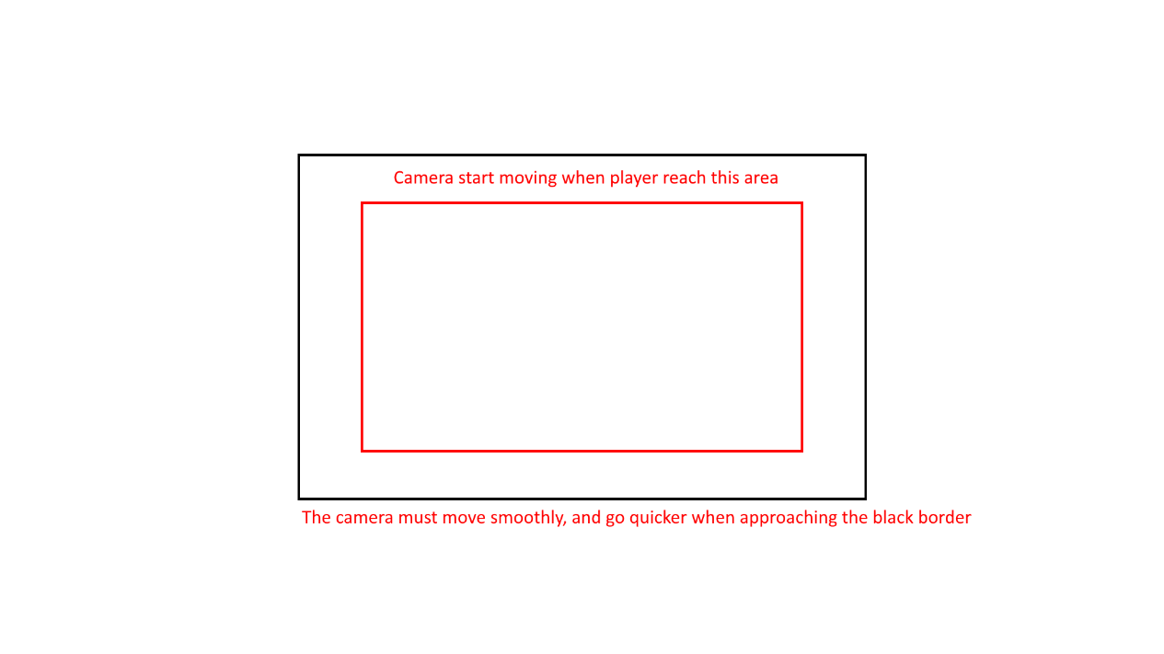

On the image above the red border is just the “free area”, the camera doesn’t move as long as the player stays in the red area. Between the red and the black, the camera starts to move. The player should never leave the black area.

**Important:** the black area is not the world border nor the window border. It is just a rectangle in the middle of the window used for the camera system.

**Conditions of satisfaction:**

* Create a “free move” area (the camera does not move)
* Have a smooth camera movement (according to the delta time)

### **Feature 8 –** Animations

Characters and some items must have animations. The game will use sprite sheet animation to do so.

**Conditions of satisfaction:**

* Have an Animation class
* Can control the playtime of the animation (loop, time of each frame, …)
* Should use the default sf::Sprite of SFML
* Can be used for every element (sprites) of the game

### **Feature 9 –** Level Builder

Use to make building levels an easier experience

**Conditions of satisfaction:**

* Draw the Builder
* Select objects
* Add/Remove/Modify objects from the map
* Export object data to a Json file

### **Feature 10 –** Menu & UI

Use to make building levels an easier experience

**Conditions of satisfaction:**

* Allows player to navigate through the game
* Gives players information on what’s happening through a HUD

### **Feature 11 –** Sound

Use to make building levels an easier experience

**Conditions of satisfaction:**

* Play Music for the game
* Add Dynamic Sounds e.g. player footsteps, zombie growling, bottle breaking

# **Game World**

# Game Geography

The game's geography is an island, so water will be used as a “border-limit” all around the map at each level. To highlight the fact that we are on an island, “beach” tiles will be used as a base for the map and other environment used to modify it. The geography is largely outdoor plants with rundown walls and furniture to highlight the abandoned nature of the place.

# Game World Elements

# Characters (Player and Enemies)

|  |  |  |  |
| --- | --- | --- | --- |
| **Name** | **Description & Appearance** | **Abilities** | **Strengths** |
| Survivor (Player) | The survivor (which is the actual player) looks like a surviving soldier.   | Can sneak, walk, and run. Each move can make noises depending on its type.   * **Sneak:** do not make noise, but is slow * **Walk:** do small noises * **Run:** do a lot of noises |  |
| Zombie | The Zombie is static unless you enter its field of vision or it hears a noise   | Chase the player or noises it hears | Can hear the player from far away. Or see the player up close |

# Items

|  |  |  |
| --- | --- | --- |
| **Name** | **Description & Appearance** | **Abilities** |
| Glass bottle | A throwable object that can be found on the ground. | Can be found on the map and thrown towards any direction and to create noise. |
| Goal | This is the target for the player, they need to find and reach the goal to progress to the next level | Allows the player to complete a level |

# **Levels**

# Level description

* Level 1: This Level is designed primarily to show off all the mechanics, 4 different terrains to the left to show off noise variance, bottles and a wall at the bottom to show off throwing objects, ground and a zombie to the right to show the noise triggering the zombie

Level 2: This level highlights the level of detail can be added to a level, there’s 2 zombies and 2 pickups along with lots of objects and walls obstructing movement

1. **Interface**

### Controls

Mouse – navigate menus

Arrow Keys – move

Left Ctrl – slower speed

Space – faster speed

P – pause menu

D – toggle debug mode

Right Ctrl – throw an object in your inventory

### HUD

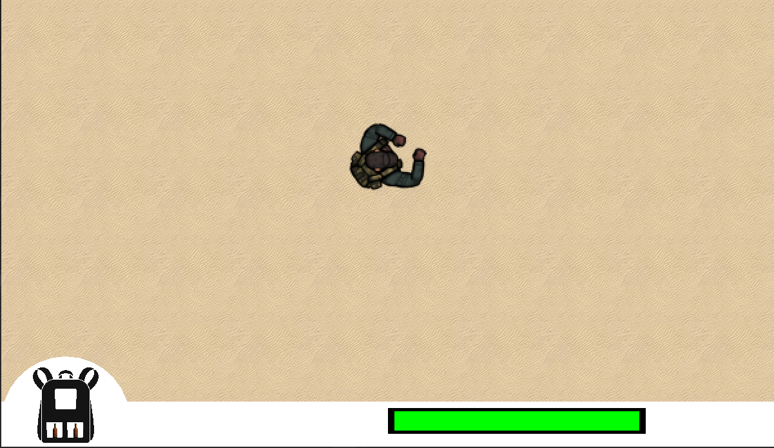

### Screenflow

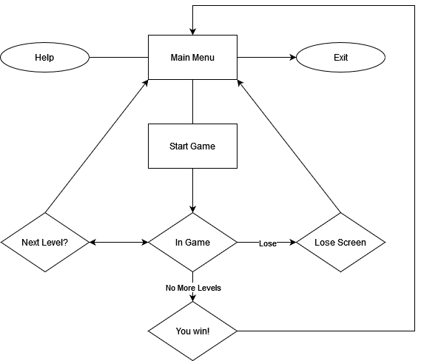

### Control system

*A mouse is used to navigate menus using buttons*

# AI

### Opponent AI

The game uses a very simple AI, one enemy keeps following the player if it can see the player and the other one just simply uses the pathfinding to get to the player`s location.

# **Game Art & Audio**

### Audio

* + 1. **Background music**

We are going to use a simple white noise for background music.

* + 1. **Audio effects**

For audio effects we are going to have simple footstep audio for player walking, we will play it faster and slower for running and crawling.

We will have random zombie noises. As soon as a player is seen by the scouting zombie that zombie will do start making loud screaming noises to attract the other zombie.

We will have glass noise and can noise for throwables.

### **Art assets**

##### **Characters/ animation frames**

For our character, we surfed the internet and borrowed a free sprite for different states of players and zombies and animated them.

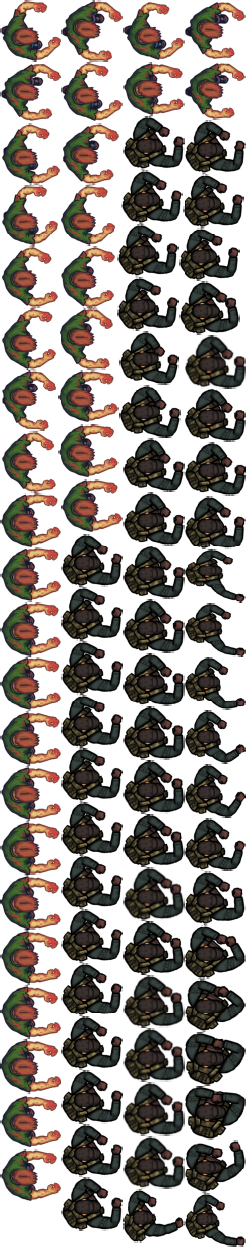

##### **Items (in-game & icons)**

For in-game items, we are going to have a glass bottle and a can for the player to collect and throw them.



##### **Level backgrounds/maps/environment textures**

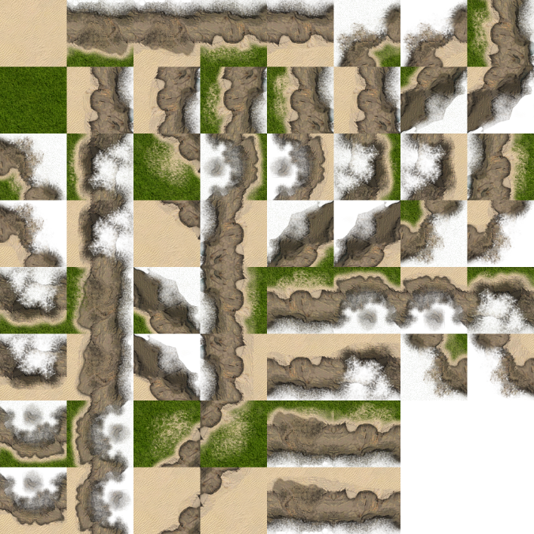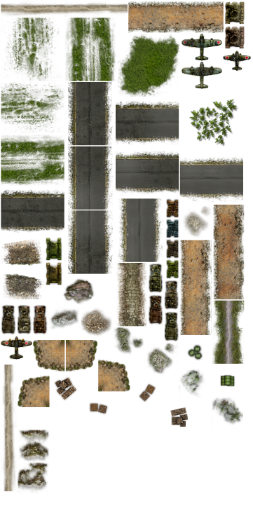

##### **Visual effects**

##### **Particles**

We are going to use a particle system for creating semi-foggy weather for our level and the blood effect of getting attacked by the zombies.

##### **HUD graphics, typeface**

Our Hud will be a simple rectangle shape on top of the window (please check the interface)

##### **Controls screen/menu/dialog backgrounds/borders/typefaces**

# 

Menu background with a simple multiple button function for the beginning of the game and a simple pause menu for in-game.